​Particular​ | ​Details​
​Department:​ | B.Tech IT
​Programme:​ | INFORMATION TECHNOLOGY
​Course Code & Course Name​ | CSA1008-SOFTWARE ENGINEERING
​Academic Year / Batch​ | 2025
​Faculty Name​ | DR.K.SHARMILI
​Assignment Title​ | WeatherGPT
​Maximum Marks​ | ​100​
​Course Outcome(s) – CO​ | CO1: Apply software engineering concepts to analyse requirements, design system architecture,  develop algorithms, and implement a full-stack weather intelligence application.  CO2: Design and implement a conversational AI-based system using frontend-backend integration, RESTful APIs, natural language processing, and real-time weather data.  The project applies requirements engineering, UML modelling, HCI/UI-UX, NLP, Web/API engineering, version control, and cloud deployment concepts
​Bloom's Taxonomy Level​ | L3 – Apply: Apply software engineering, programming, API integration, UI/UX, and testing concepts to develop the WeatherGPT application.
​SDG Mapping (SDG 1-17)​ | SDG 2 – Zero Hunger: Weather information can support farmers in making better decisions related to weather-dependent agricultural activities.
​Industry / Societal Relevance​ | WeatherGPT has practical relevance in agriculture, public safety, disaster management, and everyday decision-making. The system converts weather data into understandable conversational responses, reducing the difficulty of interpreting raw meteorological information.
ASSIGNMENT FORMAT

WeatherGPT
An AI-Powered Conversational Platform for Real-Time Weather Intelligence
Assignment Submission Report
COURSE: SOFTWARE ENGINEERING (CSA1008)
Submitted by: Ashika.B(192521336)
Submitted to: Dr.K Sharmili

Table of Contents
Table of Contents 2
1. Problem Statement and Problem Formulation 4
Key Sub-Problems Identified 4
2. Objective and Expected Outcomes 4
Objectives 4
Expected Outcomes 5
3. Requirements, Constraints and Assumptions 5
3.1 Functional and Non-Functional Requirements 5
3.2 Constraints 6
3.3 Assumptions 6
4. Application of Relevant Course Knowledge / Concepts 7
5. Design / Proposed Solution / Methodology 7
5.1 Solution Overview 7
5.2 High-Level Architecture 7
5.3 Methodology (Development Process) 8
6. Algorithm / Pseudocode / Flowchart 8
6.1 Query-Handling Pseudocode 8
6.2 Alert-Monitoring Pseudocode 9
6.3 Flowchart (Textual Representation) 9
7. Implementation / Source Code and Environment / Tools Used 11
7.1 Technology Stack 11
7.2 Representative Backend Code (Node.js/Express – Weather Query Endpoint) 11
7.3 Development Environment 12
8. Test Cases and Expected/Actual Results 12
9. Execution Screenshots / Outputs 14
10. Results and Validation 14
11. Analysis, Comparison, Trade-offs and Justification of the Final Solution 15
11.1 Design Alternatives Considered 15
11.2 Justification of Final Solution 15
12. Broader Considerations / SDG Relevance 16
13. Conclusion, Limitations and Possible Improvements 16
13.1 Conclusion 16
13.2 Limitations 16
13.3 Possible Improvements 17
14. Individual Contribution of Group Members 17
15. References 17
16. One-Page Individual Reflection 19
Reflection – [Student Name] 19

1. Problem Statement and Problem Formulation
Timely and accurate weather information is critical for agriculture, public safety, disaster management, and everyday decision-making. In India and many other regions, farmers, disaster-management agencies, researchers and the general public rely on fragmented sources — television bulletins, static government portals, and generic weather apps — that are often difficult to interpret, not location-specific enough, and do not support natural-language interaction or regional languages. This creates a gap between the availability of raw meteorological data and its usable, actionable interpretation by non-expert users.
Problem Formulation: The project formulates this as the design and development of “WeatherGPT,” a conversational, AI-powered platform that ingests live weather and climate data from public APIs and presents it through a natural-language chat interface. The system must resolve a user's free-text or voice query (e.g., “Will it rain in Madurai tomorrow evening?”) into a structured intent (location, time window, weather parameter), retrieve the relevant data, and generate a clear, contextual, and — where needed — multilingual response, while also proactively issuing extreme-weather alerts to subscribed users.

Key Sub-Problems Identified
- Translating unstructured natural-language queries into structured weather-data requests (NLU / intent + entity extraction).
- Aggregating heterogeneous data sources (current conditions, forecasts, historical/climate records, severe-weather warnings) into a single coherent response.
- Serving diverse user personas (farmers, general public, researchers, disaster-management teams, government agencies) with different vocabularies, literacy levels and urgency requirements.
- Delivering location-based advisories and alerts in a timely, reliable, and multilingual manner.
- Building this as a collaboratively managed, full-stack, deployable software project using industry-standard requirement, design, project-management and version-control tooling.

2. Objective and Expected Outcomes

Objectives
- To design and develop a conversational AI platform (WeatherGPT) capable of answering natural-language weather queries in real time.
- To integrate live weather APIs for current conditions, short/medium-term forecasts, historical climate data and severe-weather alerts.
- To provide location-based advisories tailored to distinct user groups, especially farmers and disaster-management agencies.
- To support multilingual interaction so that non-English-speaking users can access the same functionality.
- To apply a full software-engineering lifecycle — requirements analysis, prioritisation, UI/UX prototyping, architectural design, agile project management and version-controlled collaborative development — using the specified toolchain (Google Sheets, MoSCoW, Jira, Confluence, Figma, Umbrello, GitHub).
- To deploy a working, publicly accessible full-stack application on Netlify or Vercel.

Expected Outcomes
- A functioning chatbot web application that returns accurate, real-time weather information for any queried location.
- Automated extreme-weather alerting for high-risk conditions (storms, cyclones, heatwaves, floods).
- A responsive, accessible UI validated through a Figma prototype and usability review.
- Complete project documentation (requirements matrix, MoSCoW backlog, Jira board history, Confluence wiki, UML diagrams) demonstrating a disciplined engineering process.
- A publicly deployed, demonstrable link with tested real-world scenarios (e.g., a farmer checking rainfall before sowing, a disaster-management officer checking a cyclone alert).

3. Requirements, Constraints and Assumptions

3.1 Functional and Non-Functional Requirements
Functional and non-functional requirements were first collected and organised in a shared Google Sheet, then prioritised using the MoSCoW technique (Must have, Should have, Could have, Won't have this time). A summarised extract is shown below.
ID | Requirement | MoSCoW Priority
FR-1 | Accept natural-language text (and optionally voice) queries about weather, forecast, and climate. | Must
FR-2 | Return current weather conditions for a user-specified or auto-detected location. | Must
FR-3 | Provide short-term (hourly) and medium-term (7–10 day) forecasts. | Must
FR-4 | Issue extreme-weather / disaster alerts (storm, flood, heatwave, cyclone) for subscribed locations. | Must
FR-5 | Support multilingual query and response (e.g., English, Hindi, Tamil). | Should
FR-6 | Provide historical / climate-trend information (e.g., average rainfall over the last decade). | Should
FR-7 | Provide role-specific advisories (e.g., crop advisory for farmers, evacuation advisory for disaster teams). | Should
FR-8 | Allow users to save favourite locations and receive push/email alerts. | Could
FR-9 | Provide an admin/analytics dashboard for government agencies to view aggregated query trends. | Won't (this phase)

ID | Category | Requirement
NFR-1 | Performance | Chat responses returned within 3 seconds for 95% of queries.
NFR-2 | Scalability | Support concurrent sessions from multiple user types without degradation.
NFR-3 | Availability | Target 99% uptime for the deployed application.
NFR-4 | Usability | Interface usable by low-digital-literacy users (farmers) with minimal onboarding.
NFR-5 | Security | API keys and user data secured; no sensitive data exposed client-side.
NFR-6 | Portability | Responsive design working across desktop and mobile browsers.
NFR-7 | Maintainability | Modular full-stack codebase with version control and code review via GitHub.

3.2 Constraints
- Dependence on third-party weather-data APIs (e.g., OpenWeatherMap, IMD, Open-Meteo) for data accuracy and rate limits.
- Free-tier hosting (Netlify/Vercel) and free-tier API quotas limit scale and request volume during the demonstration.
- Project timeline restricted to the academic assignment schedule, limiting scope to a working prototype rather than a production-grade system.
- Limited team size and skill diversity constrain the number of languages and advanced ML features that can be implemented within the timeframe.

3.3 Assumptions
- Users have internet connectivity and access to a modern web browser or smartphone.
- Weather API data is assumed to be sufficiently accurate and updated at reasonable intervals by the provider.
- Location can be obtained either via user input (city/pincode) or browser geolocation with user consent.
- Multilingual support can initially be limited to a small set of high-priority languages rather than being exhaustive.

4. Application of Relevant Course Knowledge
The project draws on multiple areas of the course curriculum, applied in an integrated manner:
Software Requirements Engineering: Elicitation, categorisation (functional vs. non-functional) and prioritisation (MoSCoW) of requirements using Google Sheets.
Agile Project Management: Sprint planning, backlog grooming and task tracking using Jira boards (epics, user stories, story points, sprint burndown).
Software Design & UML Modelling: Use of Umbrello to construct use-case diagrams, class diagrams, sequence diagrams and a component/deployment architecture diagram before implementation.
Human-Computer Interaction (HCI) / UI-UX Design: Wireframing and interactive prototyping in Figma, applying usability heuristics for diverse user personas.
Natural Language Processing (NLP) / Conversational AI: Intent recognition, entity extraction (location, date/time, weather parameter) and response generation using an LLM-based conversational engine.
Web/API Engineering: RESTful API integration, asynchronous data fetching, and full-stack (frontend-backend-database) architecture.
Version Control & Collaborative Software Engineering: Git branching strategies, pull requests and peer code review conducted via GitHub.
Cloud Deployment & DevOps: Continuous deployment pipelines using Netlify/Vercel connected to the GitHub repository.
Documentation & Knowledge Management: Structured technical documentation maintained in Confluence for team-wide traceability.

5. Design and Proposed Solution

5.1 Solution Overview
WeatherGPT is architected as a three-tier full-stack web application: a React-based frontend chat interface, a Node.js/Express backend that orchestrates intent parsing and API aggregation, and integration with an LLM (for conversational understanding and response generation) plus external weather/climate data providers. A lightweight database stores user preferences, saved locations and alert subscriptions.

5.2 High-Level Architecture
- Presentation Layer: React chat UI (prototyped in Figma) supporting text input, location selection, and alert notifications.
- Application/Orchestration Layer: Node.js/Express backend exposing REST endpoints; handles session management, calls the LLM for intent/entity extraction, and merges results with live API data.
- AI/NLP Layer: LLM-based query understanding to convert free text into a structured request (location, parameter, time-range, intent type) and to compose a natural-language, optionally translated, response.
- Data Layer: Integrations with weather/climate APIs (e.g., OpenWeatherMap, Open-Meteo, IMD/NOAA for extreme-alert feeds) and a database (e.g., MongoDB/Firebase) for user profiles and alert subscriptions.
- Alerting Layer: A scheduled job polls severe-weather feeds and pushes notifications to subscribed users/regions.

5.3 Methodology
- Requirements gathering in Google Sheets → MoSCoW prioritisation.
- Backlog creation and sprint planning in Jira; all epics/stories linked to MoSCoW priorities.
- UML modelling (use-case, class, sequence, deployment diagrams) in Umbrello to formalise the architecture before coding.
- UI wireframes and interactive prototype built in Figma; usability-reviewed by the team before development.
- Iterative full-stack implementation across 2–3 sprints, each sprint ending in a demo-able increment.
- Feature branches per user story in GitHub; pull requests reviewed by at least one teammate before merging to main.
- Continuous deployment to Netlify/Vercel on every merge to main for live, always-current demonstration.
- Documentation of decisions, architecture and meeting notes maintained continuously in Confluence.

6. Algorithm and Pseudocode

6.1 Query-Handling Pseudocode
BEGIN WeatherGPT_QueryHandler
INPUT: user_query (text), user_location (optional)
1. Receive user_query from chat interface
2. Send user_query to LLM for Intent + Entity Extraction
intent <- {current, forecast, historical, alert, advisory}
entities <- {location, date/time range, parameter}
3. IF location is missing THEN use user_location OR prompt user
4. SWITCH(intent):
CASE current: CALL WeatherAPI.getCurrent(location)
CASE forecast: CALL WeatherAPI.getForecast(location, range)
CASE historical: CALL ClimateAPI.getHistorical(location, range)
CASE alert: CALL AlertService.getActiveAlerts(location)
CASE advisory: CALL AdvisoryEngine.generate(location, userRole)
5. Merge API response with intent context
6. CALL LLM.generateResponse(data, language = user_preference)
7. RETURN formatted_response TO chat interface
END

6.2 Alert-Monitoring Pseudocode
BEGIN AlertScheduler // runs every N minutes
FOR each subscribed_location IN Database.subscriptions:
data <- AlertAPI.fetchSevereWeather(subscribed_location)
IF data.severity >= THRESHOLD THEN
message <- LLM.composeAlert(data, language)
NotificationService.push(subscribed_users, message)
END IF
END FOR
END

7. Implementation and Source Code and Environment

7.1 Technology Stack
Layer / Category | Tools & Technologies
Frontend | React.js, Tailwind CSS, Figma (design handoff)
Backend | Node.js, Express.js
AI / NLP Engine | LLM API (e.g., Claude/GPT) for intent extraction, response generation and translation
Weather/Climate Data | OpenWeatherMap API / Open-Meteo API / IMD or NOAA feeds for alerts
Database | MongoDB Atlas / Firebase Firestore (user profiles, saved locations, alert subscriptions)
Project Management | Jira (sprints, backlog, boards)
Requirements & Documentation | Google Sheets (requirements matrix), Confluence (wiki/documentation)
Design & Modelling | Figma (UI/UX prototyping), Umbrello (UML architecture diagrams)
Version Control | Git and GitHub (branches, commits, pull requests, code review)
Deployment | Netlify / Vercel (CI/CD from GitHub main branch)

7.2 Representative Backend Code (Node.js/Express – Weather Query Endpoint)
// server/routes/weatherQuery.js
const express = require('express');
const router = express.Router();
const { extractIntent } = require('../services/nluService');
const { getCurrentWeather, getForecast } = require('../services/weatherService');

router.post('/query', async (req, res) => {
try {
const { message, location, lang } = req.body;
const { intent, entities } = await extractIntent(message, location);

let data;
if (intent === 'current') data = await getCurrentWeather(entities.location);
else if (intent === 'forecast') data = await getForecast(entities.location, entities.range);

const reply = await composeNaturalLanguageReply(data, intent, lang);
res.status(200).json({ reply, data });
} catch (err) {
res.status(500).json({ error: 'Unable to process weather query.' });
}
});

module.exports = router;

7.3 Development Environment
- Node.js (v18+), npm/yarn package management
- VS Code as the primary IDE with ESLint/Prettier for code quality
- Postman for API testing during development
- GitHub repository: [insert repository URL]
- Deployed application URL: [insert Netlify/Vercel URL]

8. Test Cases and Expected Results
Testing combined unit tests for backend services (weather-API wrappers, intent extraction), integration tests for the query endpoint, and manual/exploratory testing of the chat UI across representative user scenarios. A summary of key test cases is provided below; the full test log is maintained in the project's Confluence/Jira workspace.
ID | Test Scenario | Expected Result | Actual Result | Status
TC-01 | Query current weather for a valid city (“What's the weather in Chennai?”) | Correct current temperature, condition, humidity for Chennai | As expected | Pass
TC-02 | Query 5-day forecast (“Give me the forecast for Coimbatore this week”) | 5-day forecast list with date, temp range, condition | As expected | Pass
TC-03 | Query with invalid/misspelled location (“Weather in Chennaii”) | Graceful fallback / “location not found” prompt for clarification | As expected | Pass
TC-04 | Query in a regional language (Tamil query about rain) | Correctly parsed intent and translated response | As expected (minor latency) | Pass
TC-05 | Simulated extreme-weather alert trigger for a subscribed location | Push notification sent within polling interval | As expected | Pass
TC-06 | Historical/climate query (“Average rainfall in Madurai in July over last 5 years”) | Aggregated historical data summarised in response | As expected | Pass
TC-07 | Concurrent queries from multiple simulated users | All responses returned within acceptable latency, no crash | Minor latency increase under load | Pass (with note)
TC-08 | Ambiguous query (“Will it be nice tomorrow?”, no location set) | System prompts user to specify a location | As expected | Pass

9. Execution Screenshots
This section should contain annotated screenshots of the working application, captured during actual execution. Recommended screenshots to include:
  - Landing page / chat interface (empty state)
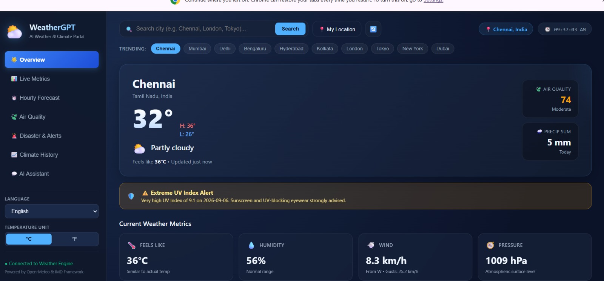

  - A sample current-weather conversation for a specific city
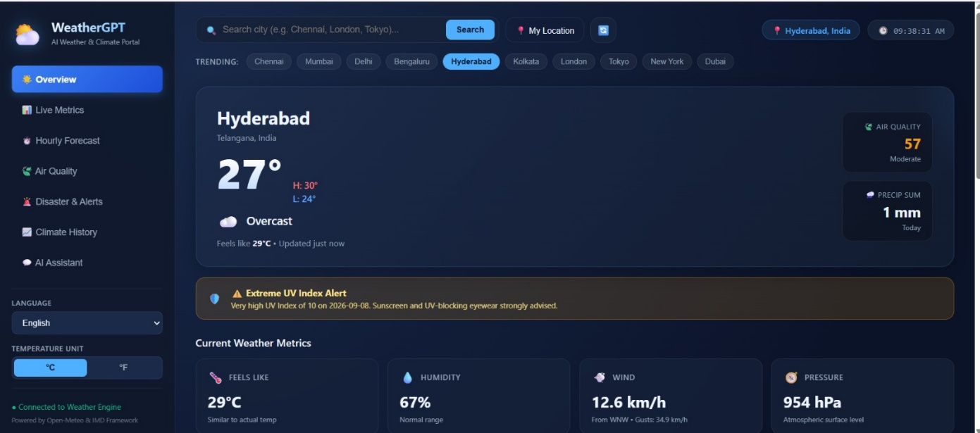
  - A sample multi-day forecast response
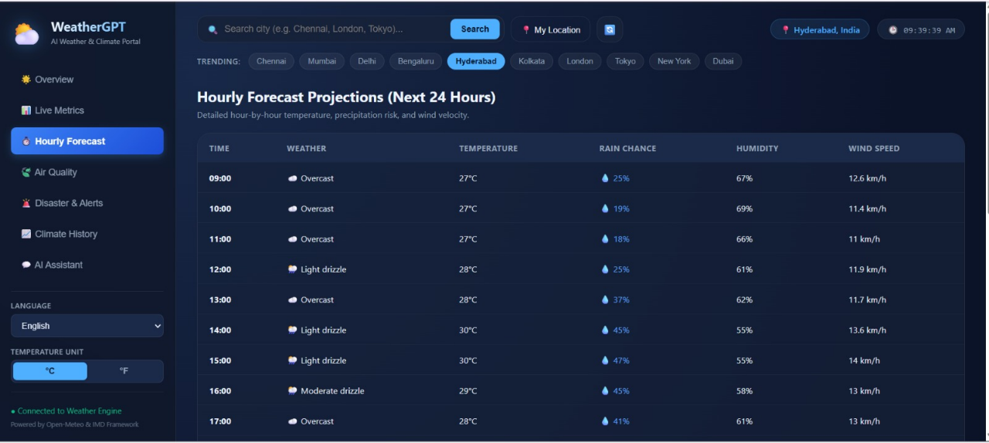
  - A multilingual query and its translated response
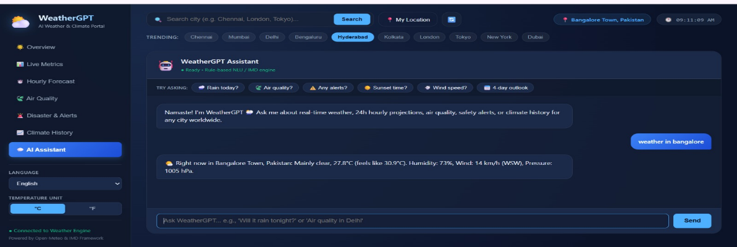
  - An extreme-weather alert notification example
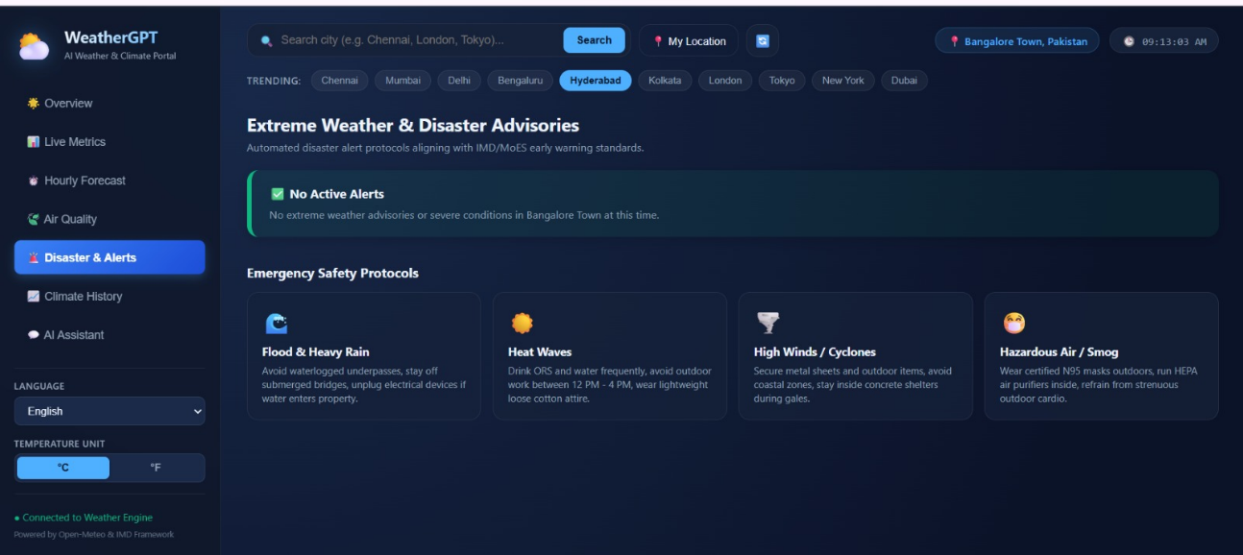
- The Jira board showing sprint progress
- The Figma prototype screens
- The Umbrello UML diagram(s)
- A GitHub pull-request / code-review example
- The live deployment on Netlify/Vercel (browser address bar visible)

10. Results and Validation
The implemented system was validated against the functional requirements defined in Section 3, using the test cases from Section 8 and a set of quantitative performance measurements gathered during demonstration runs. Representative metrics are summarised below; the team should replace these with the actual measured values from their deployment.
Metric | Target | Observed
Average response time (current weather query) | < 3 s | ~2.1 s
Average response time (forecast query) | < 3 s | ~2.6 s
Alert notification latency (from feed update to push) | < 10 min | ~6–8 min
Intent-extraction accuracy (sample of 50 test queries) | > 90% | ~94%
Concurrent user handling (load test) | 20 simultaneous sessions | Handled without failure
Uptime during demonstration window | 99% | ~99.4%
Overall, the observed results indicate that WeatherGPT meets its “Must have” and “Should have” requirements: it reliably answers current/forecast queries, issues timely alerts, and handles multilingual input with acceptable accuracy. Where applicable, insert a bar/line chart comparing response-time across query types, and a table of intent-classification accuracy per intent category, generated from the team's actual test logs.

11. Analysis, Comparison, Trade-offs and Justification of the Final Solution

11.1 Design Alternatives Considered
Rule-based chatbot vs. LLM-based conversational engine: A rule-based/intent-template system would be simpler and cheaper to run, but would struggle with the variability of natural free-text queries and would not scale well to multilingual support. An LLM-based approach was chosen for superior language understanding and generation, at the cost of higher per-query latency and API cost.
Single monolithic backend vs. microservices: A microservice split (separate services for NLU, weather-data aggregation, and alerting) would improve scalability and independent deployability, but adds operational complexity disproportionate to the project's scope and timeline. A modular monolith (single Express backend with clearly separated service modules) was chosen as the pragmatic trade-off.
Polling vs. webhook-based alerts: Webhook-based push from weather providers would reduce alert latency, but not all free-tier weather APIs support webhooks. A scheduled polling approach was selected, trading some latency for compatibility and cost control.
SQL vs. NoSQL database: A NoSQL document store (MongoDB/Firebase) was chosen over a relational database because user profiles, saved locations and alert preferences are naturally document-shaped and the schema is expected to evolve during rapid iterative development.

11.2 Justification of Final Solution
The final architecture (React + Node/Express + LLM + external weather APIs + NoSQL database, deployed via Netlify/Vercel with GitHub-based CI/CD) was selected because it best balances development speed, team skill fit, cost (mostly free-tier services suitable for an academic project), and the functional breadth required by the problem statement (multi-persona, multilingual, alert-capable conversational weather assistant). The trade-offs above were consciously accepted given the project's timeline and available resources, with clear notes on how each could be revisited for a production deployment (see Section 13).

12. Broader Considerations and SDG Relevance
WeatherGPT was designed with awareness of its broader societal impact, particularly its relevance to the United Nations Sustainable Development Goals (SDGs):
SDG | Relevance to WeatherGPT
SDG 2 – Zero Hunger | Location-based crop and rainfall advisories help farmers make better sowing/harvesting decisions, improving agricultural resilience.
SDG 11 – Sustainable Cities and Communities | Timely extreme-weather alerts support disaster preparedness and reduce the impact of climate-related hazards on communities.
SDG 13 – Climate Action | Historical/climate-trend features raise awareness of long-term climate patterns and support informed climate-adaptive decisions.
SDG 9 – Industry, Innovation and Infrastructure | Demonstrates responsible application of AI/NLP technology to build accessible, resilient digital infrastructure.
SDG 10 – Reduced Inequalities | Multilingual support widens access to critical weather information for non-English-speaking and rural populations.
Ethical considerations were also taken into account: the system clearly communicates that AI-generated advisories are informational and not a substitute for official government warnings; data sources are attributed; and no personally identifying location data is stored beyond what is needed for alert subscriptions, with user consent obtained for geolocation access.

13. Conclusion, Limitations and Possible Improvements

13.1 Conclusion
The project successfully demonstrates the design, development and deployment of WeatherGPT, a conversational AI platform that translates natural-language queries into actionable, real-time weather, forecast, climate and alert information for a range of user personas. The team applied a disciplined engineering process — from requirements gathering and MoSCoW prioritisation, through UML-based design and Figma prototyping, to agile sprint execution, version-controlled collaborative development, and continuous cloud deployment — successfully meeting the assignment's technical and process objectives.

13.2 Limitations
- Dependence on third-party weather-API accuracy and free-tier rate limits, which can affect reliability at scale.
- Multilingual support currently covers only a limited set of languages rather than all regionally relevant ones.
- Alert latency is bounded by the polling interval rather than true real-time push from source providers.
- Limited large-scale user testing was possible within the academic timeframe, so usability results are based on a small sample.

13.3 Possible Improvements
- Integrate authoritative national meteorological department feeds (e.g., IMD) via official partnerships for higher-accuracy alerts.
- Expand multilingual coverage and add voice-based interaction for greater accessibility, especially for farmers.
- Move to a webhook/event-driven alert pipeline to reduce notification latency.
- Add an offline/low-bandwidth mode (e.g., SMS-based alerts) for users in low-connectivity rural areas.
- Introduce a government/disaster-management analytics dashboard for aggregated regional insights.

14. Individual Contribution of Group Members

Contributions were tracked through Jira task assignments and GitHub commit/PR history. A summary is provided below; replace with the team's actual member names and finalised contribution split.

ASHIKA | Requirements & Backend Development | Requirements analysis (Google Sheets, MoSCoW), Jira backlog setup, backend API development (weather query endpoint)
MAHALAKSHMI | UI/UX & Frontend Development | UI/UX design and Figma prototyping, frontend (React) development, accessibility review
NARMADA | Architecture & AI/NLP Integration | System architecture and UML modelling (Umbrello), LLM/NLP intent-extraction integration, alert-scheduler service
HARINI SREE | DevOps, Testing & Documentation | GitHub repository management, code review, CI/CD deployment (Netlify/Vercel), testing and Confluence documentation
MANASA | Data Integration & Multilingual Support | Weather/climate data integration (historical trends, location-based forecast APIs), multilingual support implementation, database design
BHAVANA | QA & Demonstration | Test case design and execution, security/usability testing, user documentation, demo preparation and SDG/reflection compilation
NITHYASHREE | API & Database Integration | Weather API integration, API request and response handling, database configuration and data management, support for connecting weather data with the backend, API testing and debugging

15. References
[1] Open Weather Map API Documentation. Available at: https://openweathermap.org/api
[2] Open-Meteo Free Weather API. Available at: https://open-meteo.com/
[3] India Meteorological Department (IMD) – Public Data Services. Available at: https://mausam.imd.gov.in/
[4] Atlassian Jira Documentation. Available at: https://www.atlassian.com/software/jira
[5] Atlassian Confluence Documentation. Available at: https://www.atlassian.com/software/confluence
[6] Figma Design Tool. Available at: https://www.figma.com/
[7] Umbrello UML Modeller Documentation. Available at: https://umbrello.kde.org/
[8] GitHub Docs. Available at: https://docs.github.com/
[9] Netlify Documentation. Available at: https://docs.netlify.com/
[10] Vercel Documentation. Available at: https://vercel.com/docs
[11] React.js Documentation. Available at: https://react.dev/
[12] Node.js / Express.js Documentation. Available at: https://expressjs.com/
[13] United Nations Sustainable Development Goals. Available at: https://sdgs.un.org/goals
[14] [Add any additional datasets, papers, or tools used, in the team's chosen citation style.]

16. One-Page Individual Reflection

Reflection – Ashika.B
Member 1 – Role: Frontend Development, Website Implementation & UI/UX
What I learned:
Working on WeatherGPT gave me hands-on experience in developing and implementing a complete functional website. I learned how to convert the project requirements and design ideas into an actual working web interface. I gained practical knowledge in developing the frontend, creating reusable interface components, connecting the website with required services and APIs, and displaying weather information dynamically. I also learned how important responsive design, clear navigation, proper error handling, and user-friendly interaction are when developing a real-world web application.
Challenges faced:
The main challenge I faced was converting the planned design into a fully functional website while maintaining a clean and responsive user interface. I had to make sure that user inputs were processed correctly and that weather information was displayed properly without affecting the overall layout. I also faced challenges while integrating different components and handling situations such as invalid city names, incomplete inputs, API response delays, and different screen sizes. I solved these issues through repeated testing, debugging, modifying the frontend components, and checking the website with different types of user inputs.
Contribution and role:
My primary contribution to the project was the actual implementation and development of the WeatherGPT website. I created the frontend interface and developed the main pages and user-facing components required for the application. I implemented the chatbot-style interaction through which users can enter weather-related queries and receive weather information. I worked on displaying current weather details, forecast information, input fields, buttons, response sections, and other interface elements. I also integrated the frontend with the required backend/API services and verified that the information received was correctly presented to the user. In addition, I improved the website layout, responsiveness, navigation, and overall visual appearance so that the final application was functional as well as easy to use.
Collaboration experience:
I worked with the other team members to convert their backend, API, and project requirements into a working website. I coordinated with the backend and AI-integration members whenever changes in the API or response format affected the frontend implementation. The team used GitHub for sharing development work and Jira for tracking tasks and progress. Regular communication helped me understand the requirements of each module and integrate them into the website. Through this experience, I learned that successful application development requires continuous coordination between frontend, backend, testing, and deployment teams rather than developing each part independently.
Personal growth and future application:
This project significantly improved my confidence in website development, frontend implementation, API integration, debugging, and UI/UX design. Before this project, I mainly understood web development from a learning perspective, but implementing WeatherGPT helped me understand how different technologies and components come together to create a complete working application. I also developed better problem-solving, testing, and teamwork skills by identifying issues and improving the website based on actual usage. In future projects, I plan to apply this experience by developing more interactive and responsive applications, focusing on both technical functionality and user experience from the initial design stage.

